Watsonx.data Developer Edition Installation

(Prerequisite steps for the hands-on labs)
1. Documentation

All steps follow the steps documented in the official watsonx.data documentation:

https://www.ibm.com/docs/en/watsonxdata/1.0.x?topic=edition-installing-watsonxdata-developer-version

The main resource for this document is the official documentation above. The document is created based on the real installation on Mac OS (Intel) with 8 cores and 32 GB RAM and displays the expected responses from the installation commands. Required commands are black highlighted and responses from the system are in the normal font. Generated container names, numbers etc. in the responses can differ.

2. Operating system prerequisites
Supported OS:
- Mac OS Intel (Apple Silicon Mac is not supported)
- Linux 64 bit

Supported Virtualization Technologies:
- Docker (Mac OS, Linux)
- Podman (Linux ONLY, don’t use it in Mac)

3. Docker preparation

We suppose to use Docker for this lab.
Docker desktop with Docker engine installed. Docker desktop and engine are started.
Docker resources setting:

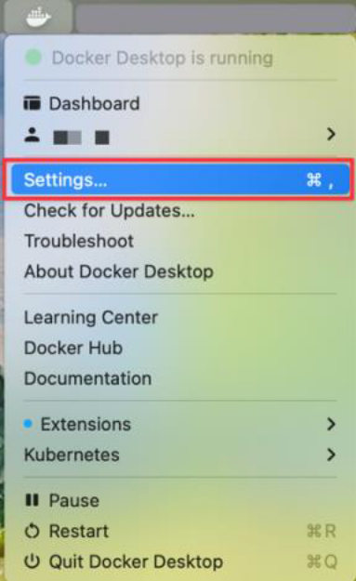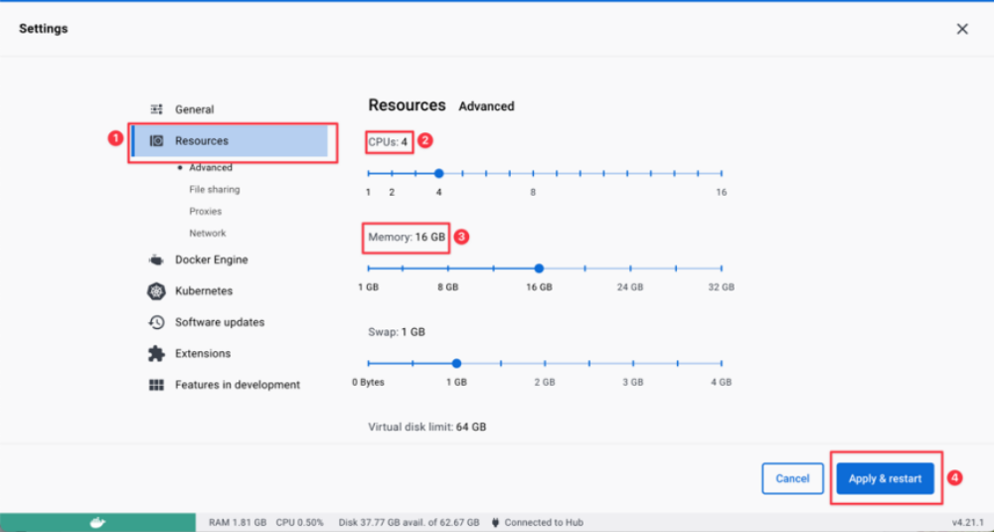

Set the reasonable number of CPUs and Memory based on the host platform resources. For example, in case of Mac or Linux with 8 cores and 32 GB, set 4 CPUs and 16 GB Memory.
Apply & restart Docker Desktop after resource setting.

4. Entitlement Key

Get the entitlement key from the IBM Entitled Registry:
https://myibm.ibm.com/products-services/manage/products-services/containerlibrary

After logging with your IBM ID Add new key (1) or Delete (2) the existing one and create the new one with Add new key (1) (recommended step if there is some existing old key):

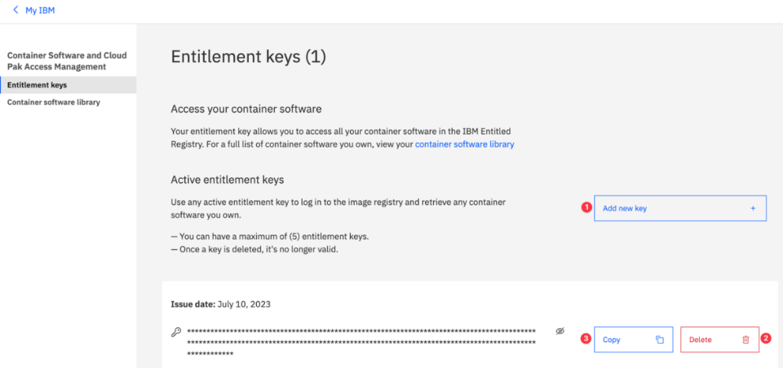

Copy (3) the key (IBM_ENTITLEMENT_KEY) and store it for the usage later.

5. Set up the install directory and environment variables

a) Set up the work directory
~ $ mkdir WATSONX
~ $ cd WATSONX
~/WATSONX $

b) Set the environment variables
cat <<EOF > chenv
export LH_ROOT_DIR=~/WATSONX
export LH_IMAGE_TAG=latest
export IBM_LH_TOOLBOX=cp.icr.io/cpopen/watsonx-data/ibm-lakehouse-toolbox:$LH_IMAGE_TAG
export LH_REGISTRY=cp.icr.io/cp/watsonx-data
export PROD_USER=cp
export IBM_ENTITLEMENT_KEY=<Entitlement key string from step (4)>
export DOCKER_EXE=docker
EOF
~/WATSONX $ cat chenv
export LH_ROOT_DIR=~/WATSONX
export LH_IMAGE_TAG=latest
export IBM_LH_TOOLBOX=cp.icr.io/cpopen/watsonx-data/ibm-lakehouse-toolbox:latest
export LH_REGISTRY=cp.icr.io/cp/watsonx-data
export PROD_USER=cp
export IBM_ENTITLEMENT_KEY=<Entitlement key string from step (4)>
export DOCKER_EXE=docker
~/WATSONX $
~/WATSONX $ chmod +x chenv
~/WATSONX $ . ./chenv
~/WATSONX $
Note: The last command should be run as <dot><space><dot><slash>chenv

6. Pull the watsonx.data developer package and copy it to the host system

~/WATSONX $ $DOCKER_EXE pull $IBM_LH_TOOLBOX
latest: Pulling from cpopen/watsonx-data/ibm-lakehouse-toolbox
6c53be4efe39: Pull complete
15e4a48aed22: Pull complete
680025b45ecc: Pull complete
7b23319732d5: Pull complete
d10745aa6766: Pull complete
e2c8b3013ea1: Pull complete
45a8fdbae51d: Pull complete
Digest: sha256:e9c02c23f367a58b911b65ca0f843a62a42c920bb12305dd2e28917aea2fcfbb
Status: Downloaded newer image for cp.icr.io/cpopen/watsonx-data/ibm-lakehouse-toolbox:latest
cp.icr.io/cpopen/watsonx-data/ibm-lakehouse-toolbox:latest
~/WATSONX $ id=$($DOCKER_EXE create $IBM_LH_TOOLBOX)
~/WATSONX $ $DOCKER_EXE cp $id:/opt - > /tmp/pkg.tar
~/WATSONX $ $DOCKER_EXE rm $id
33379bdb76a25055af28a360c43ecc5a0f1544b32321a70b1094a64bd37de2de
~/WATSONX $ id=
~/WATSONX $ docker images
REPOSITORY TAG IMAGE ID CREATED SIZE
cp.icr.io/cpopen/watsonx-data/ibm-lakehouse-toolbox latest 8a1446858fa3 7 days ago 209MB

7. Extract the watsonx.data developer version

~/WATSONX $ tar -xf /tmp/pkg.tar -C /tmp
~/WATSONX $ cat /tmp/opt/bom.txt
Description
-----------
This ibm-lh-toolbox image contains the watsonx.data client package, the watsonx.data developer package and the installation & management script for the watsonx.data standalone edition on Red Hat OpenShift.
Extract the files that you need from this image as needed to your file system. Follow the instructions in watsonx.data IBM docs on setting up and using these packages.
version: v1.0.0
build: 1002-20230706-024004-sw_dev_ent
Directory structure
-------------------
/opt/
+-- bom.txt
+-- client
+-- ibm-lh-client-v1.0.0.tgz
\-- README.txt
+-- dev
+-- ibm-lh-dev-v1.0.0.tgz
\-- README.txt
\-- standalone
+-- ibm-lakehouse-manage
\-- README.txt

Checksum
--------
# cksum /opt/*/*
3149781350 152 /opt/client/README.txt
2398490401 771114 /opt/client/ibm-lh-client-1002-20230706-024004-sw_dev_ent.tgz
1619773671 155 /opt/dev/README.txt
226390148 777632 /opt/dev/ibm-lh-dev-1002-20230706-024004-sw_dev_ent.tgz
980185898 160 /opt/standalone/README.txt
4188898317 9994 /opt/standalone/ibm-lakehouse-manage
~/WATSONX $ cksum /tmp/opt/*/*
3149781350 152 /tmp/opt/client/README.txt
2398490401 771114 /tmp/opt/client/ibm-lh-client-1002-20230706-024004-sw_dev_ent.tgz
1619773671 155 /tmp/opt/dev/README.txt
226390148 777632 /tmp/opt/dev/ibm-lh-dev-1002-20230706-024004-sw_dev_ent.tgz
980185898 160 /tmp/opt/standalone/README.txt
4188898317 9994 /tmp/opt/standalone/ibm-lakehouse-manage
~/WATSONX $ export LH_IMAGE_TAG=1002-20230706-024004-sw_dev_ent
~/WATSONX $ tar -xf /tmp/opt/dev/ibm-lh-dev-$LH_IMAGE_TAG.tgz -C $LH_ROOT_DIR
~/WATSONX $ ls
chenv ibm-lh-dev
~/WATSONX $ ls ibm-lh-dev/
README.txt bin default-config etc examples licenses localstorage run

8. Authenticate with the registry

~/WATSONX $ $DOCKER_EXE login ${LH_REGISTRY} \
--username=${PROD_USER} \
--password=${IBM_ENTITLEMENT_KEY}
WARNING! Using --password via the CLI is insecure. Use --password-stdin.
Login Succeeded

9. Run the setup script

~/WATSONX $ $LH_ROOT_DIR/ibm-lh-dev/bin/setup --license_acceptance=y --runtime=$DOCKER_EXE
======= updating configuration =======
creating /Users/janmusil/WATSONX/ibm-lh-dev/localstorage/volumes/infra
==== pulling image for lhconsole-ui from cp.icr.io/cp/watsonx-data ====
1002-20230706-024004-sw_dev_ent: Pulling from cp/watsonx-data/lhconsole-ui
.. . .. . .. . ..
==== pulling image for lhconsole-nodeclient from cp.icr.io/cp/watsonx-data ====
1002-20230706-024004-sw_dev_ent: Pulling from cp/watsonx-data/lhconsole-nodeclient
.. . .. . .. . ..
==== pulling image for lhconsole-javaapi from cp.icr.io/cp/watsonx-data ====
1002-20230706-024004-sw_dev_ent: Pulling from cp/watsonx-data/lhconsole-javaapi
.. . .. . .. . ..
==== pulling image for lhconsole-api from cp.icr.io/cp/watsonx-data ====
1002-20230706-024004-sw_dev_ent: Pulling from cp/watsonx-data/lhconsole-api
.. . .. . .. . ..
==== pulling image for ibm-lh-control-plane-prereq from cp.icr.io/cp/watsonx-data ====
1002-20230706-024004-sw_dev_ent: Pulling from cp/watsonx-data/ibm-lh-control-plane-prereq
.. . .. . .. . ..
==== pulling image for ibm-lh-minio from cp.icr.io/cp/watsonx-data ====
1002-20230706-024004-sw_dev_ent: Pulling from cp/watsonx-data/ibm-lh-minio
.. . .. . .. . ..
==== pulling image for ibm-lh-postgres from cp.icr.io/cp/watsonx-data ====
1002-20230706-024004-sw_dev_ent: Pulling from cp/watsonx-data/ibm-lh-postgres
.. . .. . .. . ..
==== pulling image for lh-hive-metastore from cp.icr.io/cp/watsonx-data ====
1002-20230706-024004-sw_dev_ent: Pulling from cp/watsonx-data/ibm-lh-hive-metastore
.. . .. . .. . ..
==== pulling image for ibm-lh-presto from cp.icr.io/cp/watsonx-data ====
1002-20230706-024004-sw_dev_ent: Pulling from cp/watsonx-data/ibm-lh-presto
.. . .. . .. . ..
=== generating self signed cert in /mnt/infra/tls ===
Generating a RSA private key
...............+++++
..................................................................................................................+++++
writing new private key to '/mnt/infra/tls/cert.key'
-----
Importing keystore /mnt/infra/tls/cert.p12 to /mnt/infra/tls/lh-ssl-ks.jks...
Certificate was added to keystore
Adding password for user ibmlhadmin
Updating password for user ibmlhadmin
~/WATSONX $

10. Start the containers

~/WATSONX $ $LH_ROOT_DIR/ibm-lh-dev/bin/start
-- starting container for ibm-lh-minio...
e9764c0a135c19a1ccad77f9f549695e9b0246d13522f5dd5e234830cfc0dcd2
-- starting container for ibm-lh-postgres...
463d20e46845d9c9af2a5bdd35cf533c0db01d7b55c97ceeda2ae679a5d198cc
Checking container: ibm-lh-postgres
Container ID for ibm-lh-postgres is: 463d20e46845
Postgres status is:
localhost:5432 - no response localhost:5432 - accepting connections
-- starting container for ibm-lh-control-plane-prereq...
-- starting container for lhconsole-api...
57dc6fde782ae2ecd6f02d71f2bd582056a04c95902488764d2219ba177dd260
-- starting container for lh-hive-metastore...
a588287a8d83cfc5781b3bd453b2fceda900f98fd1512dbc8b0e5cd008f6a118
-- starting container for ibm-lh-presto...
78198e8860493ed8a8072f748b2e8cbd1fe4b5a30f25ee940403bbb808befab0
Waiting for ibm-lh-presto to be ready....
-- starting container for lhconsole-javaapi...
e833782e406f0fbec4c717a4ff2a2dac3d89804f9cade492e7dfb46c959f19ec
-- starting container for lhconsole-nodeclient...
0c2d93f08ef0d063773749278ab1b68f2a54ce19a969f00a40625c8bf1360423
-- starting container for lhconsole-ui...
11b0cf75d70e73c7012d1e70c2a5ba3df43c3267c2f7b5039688f1773f2a0835
~/WATSONX $
11. Check the status of all the containers

~/WATSONX $ $LH_ROOT_DIR/ibm-lh-dev/bin/status --all
ibm-lh-hive-metastore running
ibm-lh-minio running
ibm-lh-postgres running 5432/tcp
ibm-lh-presto running 0.0.0.0:8443->8443/tcp
lhconsole-api running 3333/tcp, 8081/tcp
lhconsole-javaapi-svc running 8667/tcp
lhconsole-nodeclient-svc running 3001/tcp
lhconsole-ui running 0.0.0.0:9443->8443/tcp
~/WATSONX $

12. Open the watsonx.data console

https://localhost:9443/

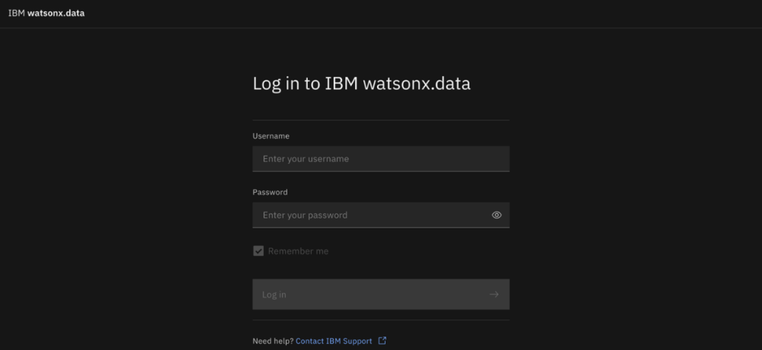
Username: ibmlhadmin
Password: password
Open the Infrastruct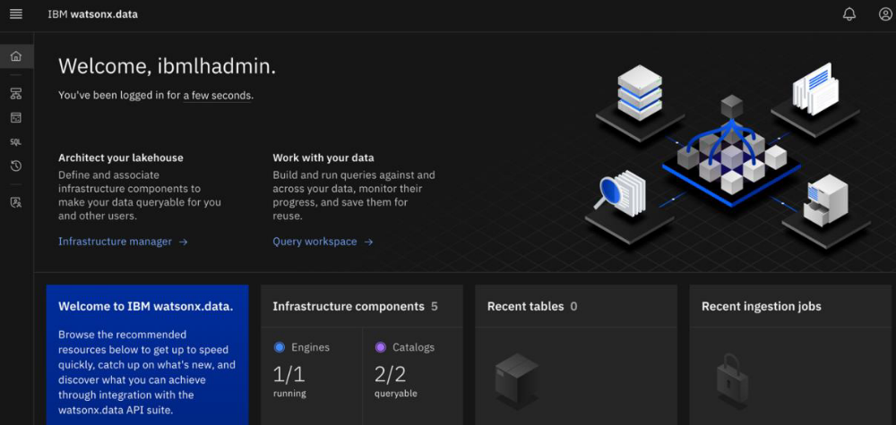open the infrastructure Manager:
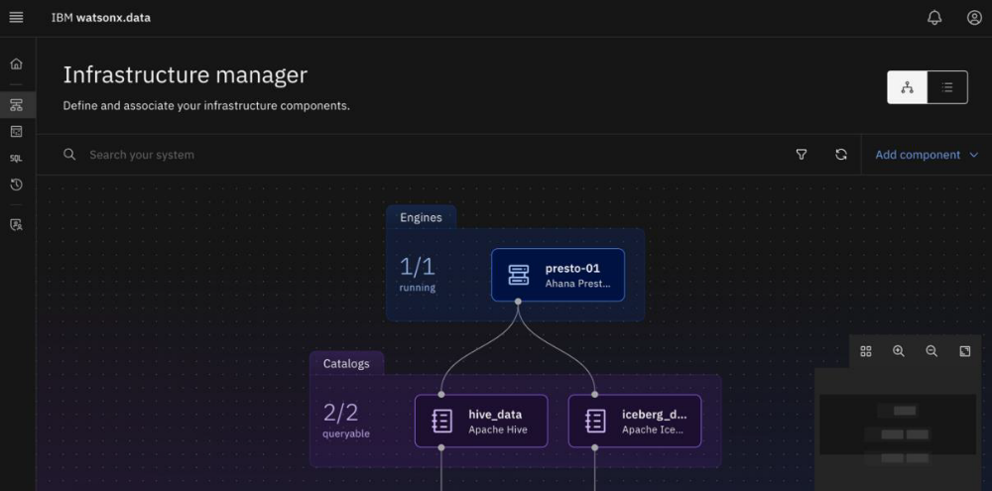

If you see the above output, you successfully finished the prerequisites lab.

